|  |  |
| --- | --- |
| Course Name | ITD 2313 – Script Programming |
| Instructor | Mr. Pranger |
| Student Name | Trey Mobley |
| Due date | 05/12/2021 |
| Grade | <grade earned here> |
| Grading Comments | <instructor comments here> |

Project #2

1.

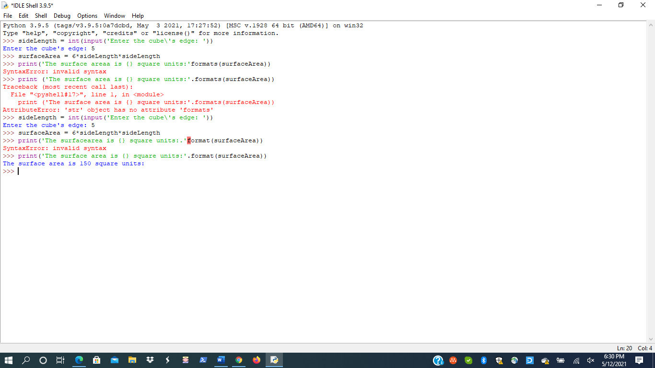

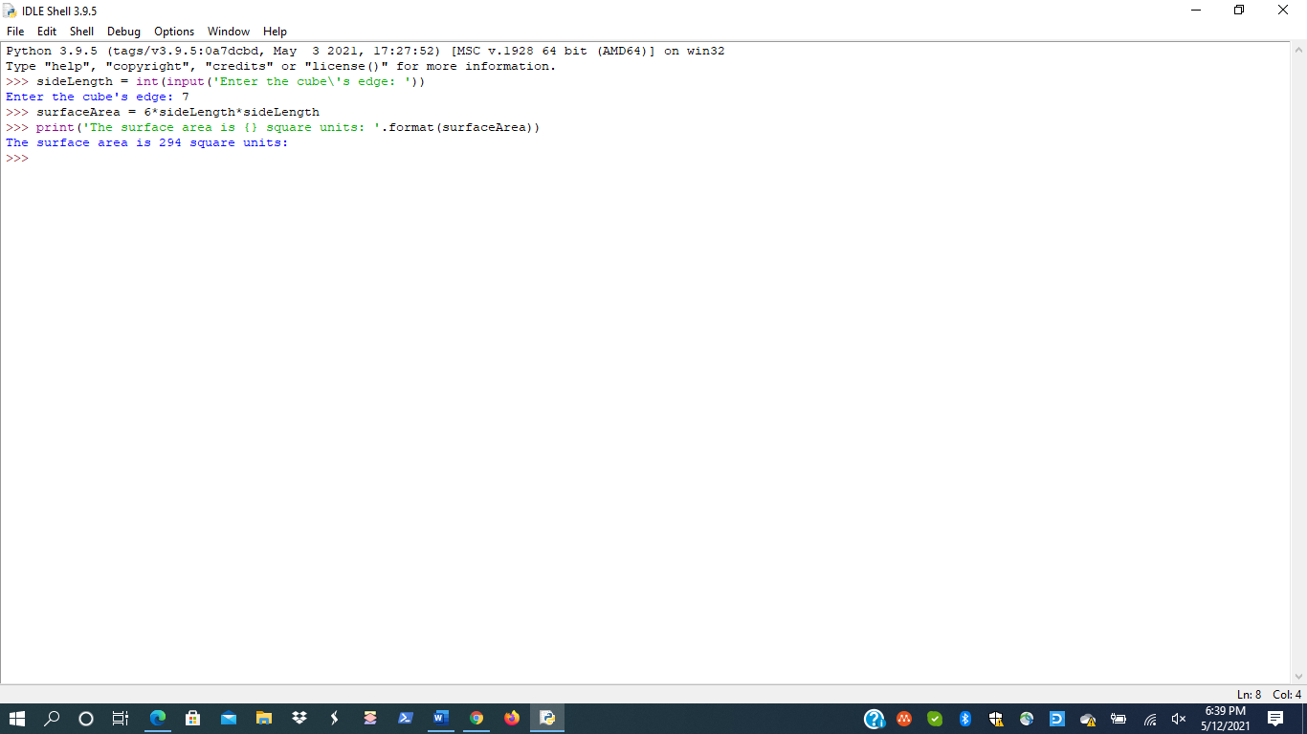

Project #3

1.

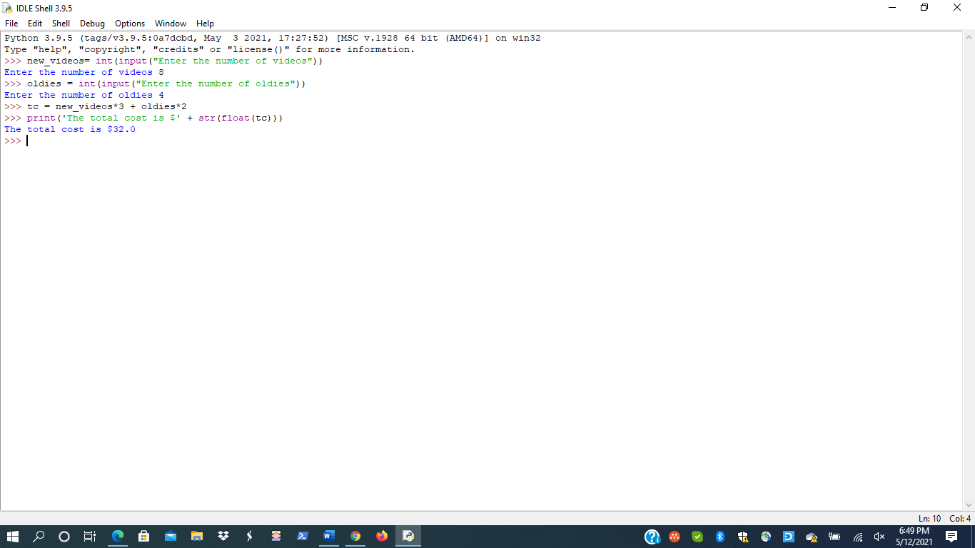

Project #5

1.

